**Practical 4: Using JFLAP, create a DFA from a given regular expression.**

**Aim:** Using JFLAP, create a DFA from a given regular expression. All types of error must be checked during the conversion.

**What is JFLAP: -**

JFLAP program makes it possible to create and simulate automata. Learning about automata with pen and paper can be difficult, time consuming and error-prone. With JFLAP we can create automata of different types and it is easy to change them as we want. JFLAP supports creation of DFA and NFA, Regular Expressions, PDA, Turing Machines, Grammars and more.

**Setup: -**

JFLAP is available from the homepage: (www.JFLAP.org). From there press “Get FLAP” and follow the instructions. You will notice that JFLAP have a .JAR extension. This means that you need Java to run JFLAP. With Java correctly installed you can simply select the program to run it. You can also use a command console run it from the files current directory with, Java –jar JFLAP.jar.

**Using JFLAP: -**

When you first start JFLAP you will see a small menu with a selection of eleven different automata and rule sets. Choosing one of them will open the editor where you create chosen type of automata. Usually you can create automata containing states and transitions but there is also creation of Grammar and Regular Expression which is made with a text editor.

**DFA from a given regular expression: -**

First, we need to select Regular Expression from the JFLAP Menu.

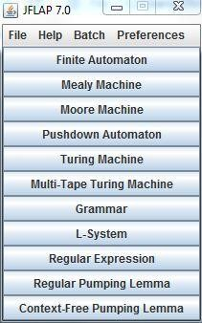

Now you should have an empty window in front of you. You will have a couple of tools and features at your disposal.

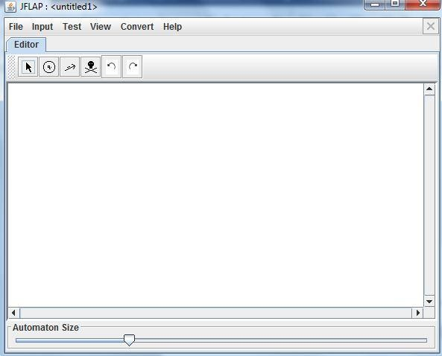

The toolbar contains six tools, which are used to edit automata.

**Attribute Editor Tool,** changes properties and position of existing states and transitions.

**State Creator Tool,** creates new states. **Transition Creator Tool,** creates transitions. **Deletion Tool,** deletes states and transitions.

**Undo/Redo,** changes the selected object prior to their history.

Regular Expressions can be typed into JFLAP to be converted to an NFA

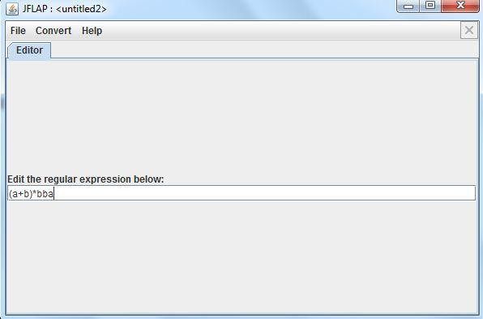

Choose Regular Expression in the main menu, then just type the expression in the textbox. Definitions for Regular Expressions in JFLAP:

* **Kleene Star**
* **+ Union**
* **! Empty String**

Correctly written expressions can then be converted to an NFA. To convert your expression select Convert → Convert to NFA. The conversion will begin with two states and a transition with your Regular Expression. With the (D)e-expressionify Transition tool you can break down the Regular Expression into smaller parts. Each transition will contain a sub expression. The next step is to link every rule with lambda transitions. Add new transition between states that should be connected with the Transition Tool. If you are unsure what to do you can select Do Step to automatically make the next step. If you want the NFA immediately Do All creates the whole NFA for you.

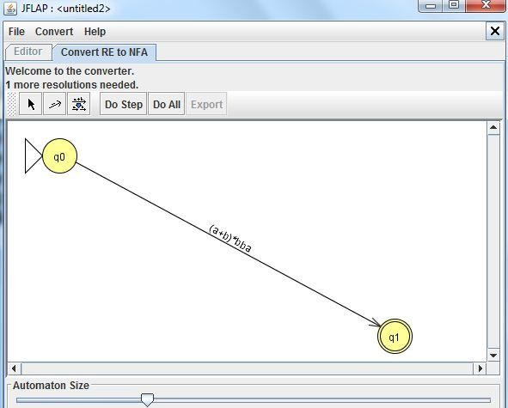

You can notice how the conversion differs depending on how the Regular Expression looks. For example the expression a+b results in a fork, were either ‘a’ or ‘b’ can be chosen.

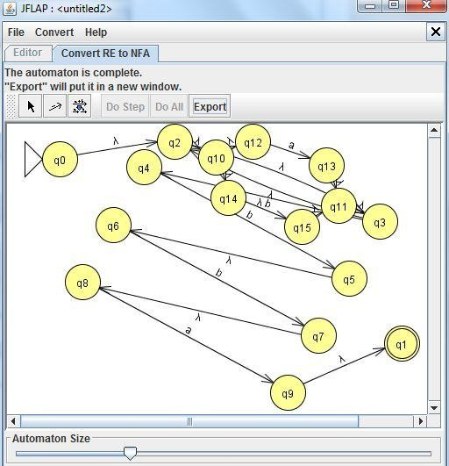

Now finally convernt NFA to DFA:-

